Test Case: tc001_SPX_Dev5_Crear_Requisicion_Spot_Tipo_Cobro_CC
Step 1 - Enter username and password and click to button Enter : Credentials Entered
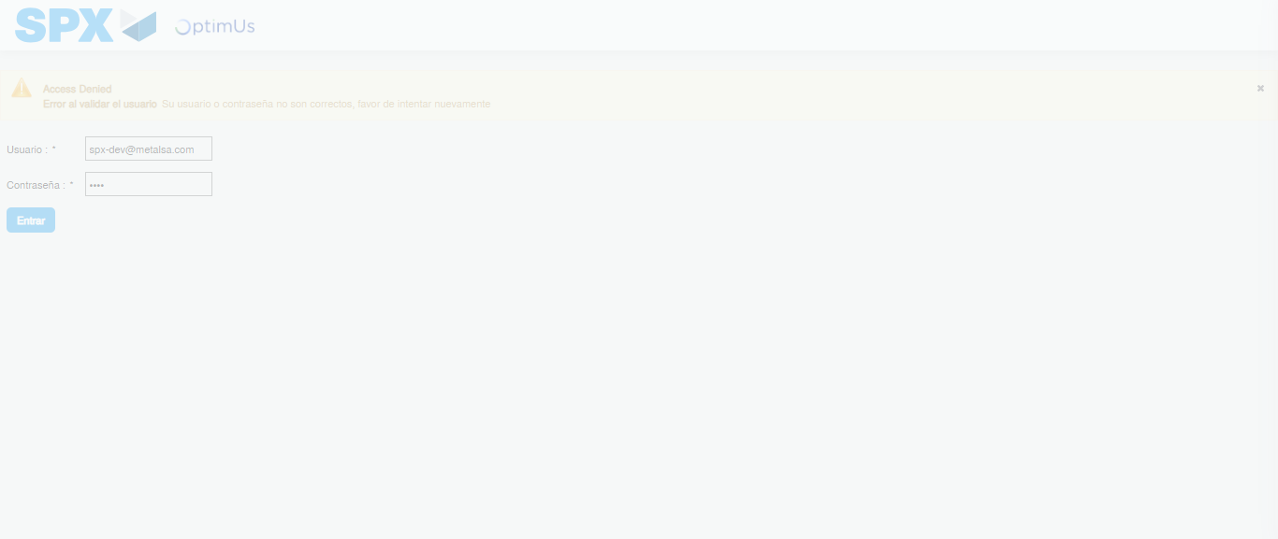Image file-name: QC_Testing-tc001_SPX_Dev5_Crear_Requisicion_Spot_Tipo_Cobro_CC-1783978948172

Step 2 - Select to UEN and Access to Spot Buy Requisitions : UEN Correctly selected and Correct access
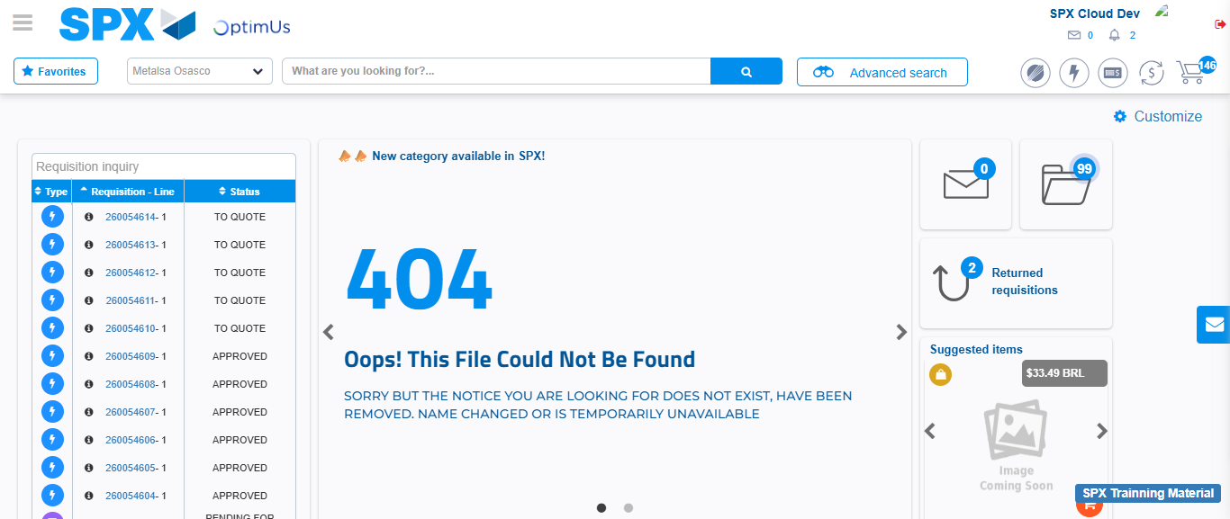Image file-name: QC_Testing-tc001_SPX_Dev5_Crear_Requisicion_Spot_Tipo_Cobro_CC-1783978973589

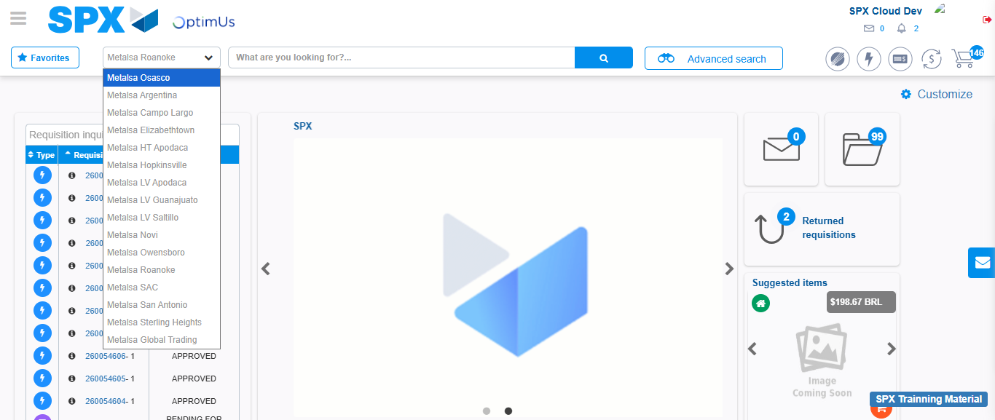Image file-name: QC_Testing-tc001_SPX_Dev5_Crear_Requisicion_Spot_Tipo_Cobro_CC-1783978976461

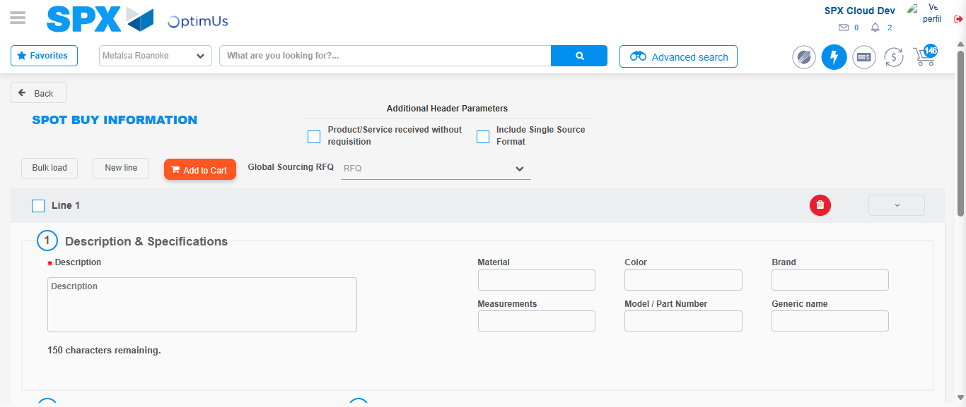Image file-name: QC_Testing-tc001_SPX_Dev5_Crear_Requisicion_Spot_Tipo_Cobro_CC-1783978998346

Step 3 - Data Capture Spot Buy Requisition : Data captured correctly
Image file-name: QC_Testing-tc001_SPX_Dev5_Crear_Requisicion_Spot_Tipo_Cobro_CC-1783978998672

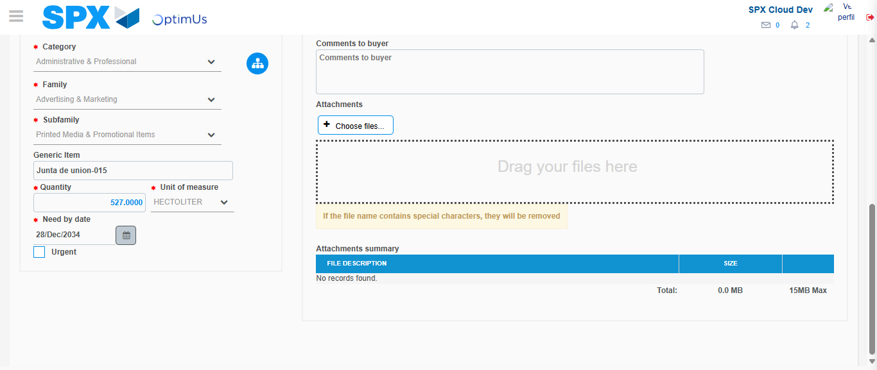Image file-name: QC_Testing-tc001_SPX_Dev5_Crear_Requisicion_Spot_Tipo_Cobro_CC-1783979009694

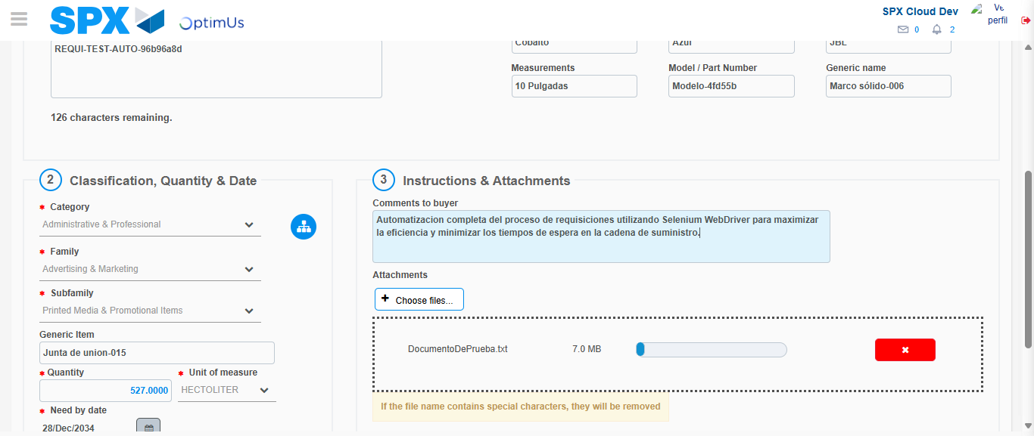Image file-name: QC_Testing-tc001_SPX_Dev5_Crear_Requisicion_Spot_Tipo_Cobro_CC-1783979010653

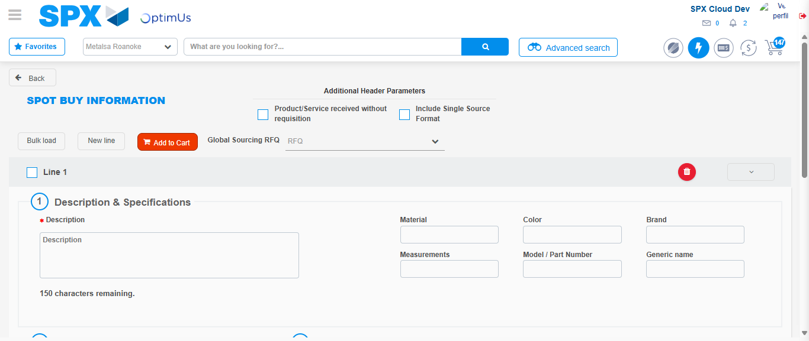Image file-name: QC_Testing-tc001_SPX_Dev5_Crear_Requisicion_Spot_Tipo_Cobro_CC-1783979021292

Step 7 - Return to Main Page SPX : Return to Main Page SPX
Image file-name: QC_Testing-tc001_SPX_Dev5_Crear_Requisicion_Spot_Tipo_Cobro_CC-1783978973589

Image file-name: QC_Testing-tc001_SPX_Dev5_Crear_Requisicion_Spot_Tipo_Cobro_CC-1783978976461

Image file-name: QC_Testing-tc001_SPX_Dev5_Crear_Requisicion_Spot_Tipo_Cobro_CC-1783978998346

Image file-name: QC_Testing-tc001_SPX_Dev5_Crear_Requisicion_Spot_Tipo_Cobro_CC-1783979023528

Image file-name: QC_Testing-tc001_SPX_Dev5_Crear_Requisicion_Spot_Tipo_Cobro_CC-1783979023716

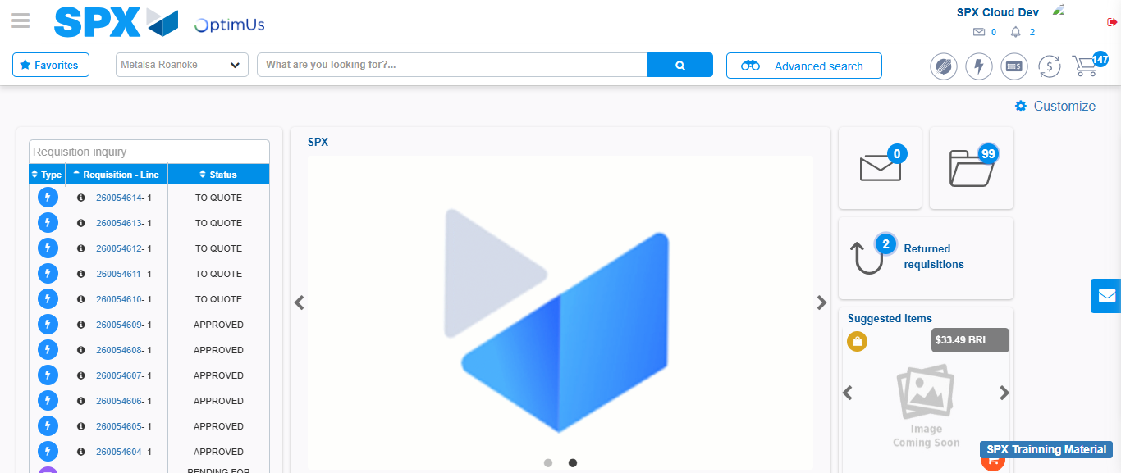Image file-name: QC_Testing-tc001_SPX_Dev5_Crear_Requisicion_Spot_Tipo_Cobro_CC-1783979044893

Step 8 - Log Out : Log Out SPX
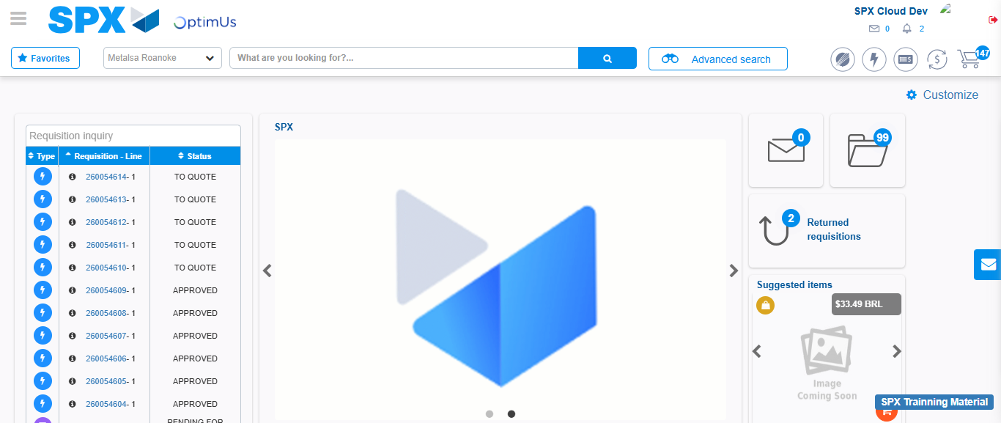Image file-name: QC_Testing-tc001_SPX_Dev5_Crear_Requisicion_Spot_Tipo_Cobro_CC-1783979045296

